The Guideline for Annotation of Social/Behavior determinants of Health (SBDoH) in Clinical Notes

Annotation task overview
Social/behavior determinants have become key factors influence patients’ Health. Although this information is valuable for doctors and researchers to get insightful understanding of the patients’ health history and develop personalized treatment plan.

General guidelines for SBDoH concept
We are interested in all types of SBDoH mentions in the clinical notes. As the first task, we aim to extract all associated mentions of the SBDoH. We have a list of annotation types in the next section with examples and definitions.

Annotation categories
In this section we will define a series concept tags for annotation, all the annotated entities should be in one of these categories. Annotators should copy the following tags into the annotation config file under [entity].

FINACIAL_CONSTRAIN
PROVERTY
OCCUPATION
EDUCATION_GENERAL
EDUCATION_HIGHLEVEL
EDUCATION_OCCUPATIONAL
EDUCATION_CHILDHOOD
PRIAMRY_CARE
HEALTH_CARE
LANGUAGE
LITERACY
PHYSICAL_ACTIVITY
SOCIAL_COHENSION
SOCAIL_SUPPORT
LIVING_SUPPLY
LIVING_CONDITION
WORKING_CONDITION
SMOKING
ALCOHOL
ALCOHOL_ABUSE
DRUG_ABUSE
SEXUAL_ACTIVITY
MARITAL_STATUS
ABUSE
IPV
PUBLIC_SAFETY
PERSONAL_SAFETY
GENEDER
RACE
ETHNICITY

The table below contains a few definitions or explains of the tags above
TAG | Definition or description | Example
FINACIAL_CONSTRAIN | any things indicate patients have temporary or current final problem but not in a poverty status
PROVERTY
EMPLOYMENT_STATUS | employment or unemployment status  (three categories: employed, unemployed, retired)
OCCUPATION | position details (e.g., track driver, work in Walmart, dept of law)
EDUCATION_GENERAL
EDUCATION_HIGHLEVEL | college and above
EDUCATION_OCCUPATIONAL | education related to professional training not degree training
EDUCATION_CHILDHOOD | early childhood development; only apply to kids before school
ACC_PRIAMRY_CARE (merge with health care) | The category will focus on whether patients have access to primary care  primary care as “the provision of integrated, accessible health care services by clinicians who are accountable for addressing a large majority of personal health care needs, developing a sustained partnership with patients, and practicing in the context of family and community.” A primary care provider is usually an internist, family physician, pediatrician, or non-physician provider (e.g., family nurse practitioner, physician assistant).  The primary care should be care happened in community clinics or family.
ACC_HEALTH_CARE | The category will focus on whether patients have access to health care.  health care as the “timely use of personal health services to achieve the best possible health outcomes.  The health care should be care happened in medical institutions or hospitals.  Focus on lack of accessibility cases since most patients should be treated as being able to access the health care.
LANGUAGE
LITERACY | knowledge level
PHYSICAL_ACTIVITY
SOCIAL_COHENSION | whether connect to society
SOCIAL_SUPPORT | whether receive support from society or community
LIVING_SUPPLY | whether have enough and safe food, drinks and other living goods
LIVING_CONDITION | homeless, shelter, whom live with
WORKING_CONDITION
SMOKING | Both smokable and smokeless tobacco will be counted for smoking
ALCOHOL | general alcohol use information
ALCOHOL_ABUSE | overdose alcohol use
DRUG_ABUSE | any drug (narcotics) use will be recognized as drug abuse
SEXUAL_ACTIVITY
MARITAL_STATUS
ABUSE | physical or mental abuse; general abuse or violence mention
IPV | A specific type of abuse for intimate partners
PUBLIC_SAFETY
PERSONAL_SAFETY
GENEDER
RACE
ETHNICITY

General examples for annotation
Note: in previous rounds, we did not annotate “not on file” or “none”, but these two should be one of the status even though we do not care (For annotation consistency). Thus, we will include them this time. We only care what is in the notes, we do not do any inference or guess. The goal is to annotate all the terms related to SDoH.

Substance use
As all substance uses have status mention in notes, we will not create status concept for each of them but will use “Substance_use_status”.
Tobacco – we will annotate 1) tobacco use mention (smoking); 2) smoking status (current, former, never); 3) type (cigarettes, cigar, smokeless tobacco); 4) frequency (ppd, py, sy, qy, other); 5) other
Concept: Tobacco; Substance_use_status; Smoking_type; Smoking_freq_ppd; Smoking_freq_sy; Smoking_freq_py; Smoking_freq_qy; Smoking_freq_other; Smoking_other
Relation: Tobacco to Substance_use_status and Substance_use_status to all others
Examples:
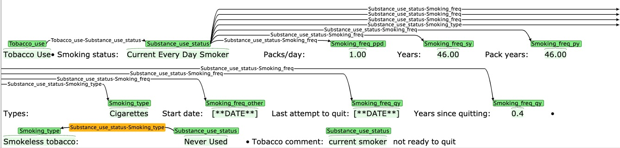
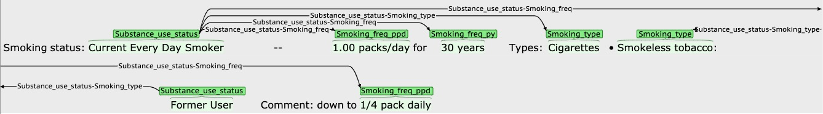
To do
[Current everyday] [smoker]

Nonsmoker
[[Nonsmoker]] tobacco use and status

Alcohol – we will annotate 1) alcohol use mention; 2) status (yes, no, abuse, quit); 3) frequency (how much per time, how often drink); 4) type; 5) other
Note: we will not annotate abuse anymore. All substance abuse become part of status
Concepts: Alcohol; Substance_use_status; Alcohol_freq; Alcohol_type; Alcohol_other
Relation: Alcohol to others
Examples:
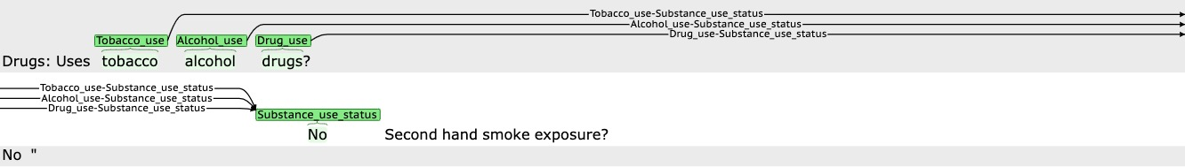
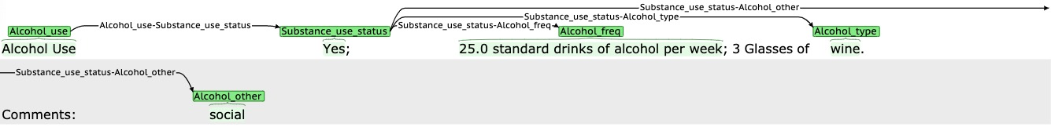

Drug – we will annotate 1) drug use mention (drug); 2) status (yes, no, abuse); 3) type (what kind of drugs); 4) frequency (how much per time); 5) other (e.g., purpose)
Note: we will not annotate abuse anymore. All substance abuse become part of status
Concepts: Drug; Substance_use_status; Drug_freq; Drug_type; Drug_other
Relation: Drug to others
Examples:
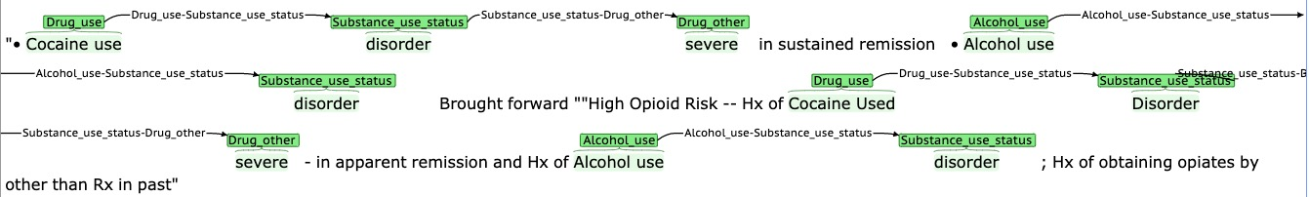

Sexual activity
We will annotate 1) sexual activity mention; 2) status (yes or no); 3) partner; 4) birth control/protection
Concepts: Sex_act; Sdoh_status; Partner; Protection
Relation: Sex_act to others
Examples:
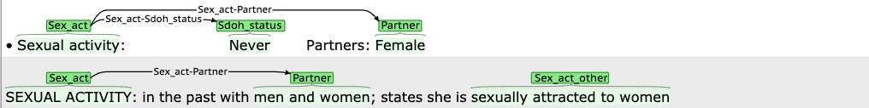

Marital status
We will annotate the mentions of marriage status: single, married, divorce etc.
Concepts: Marital_status
Examples:
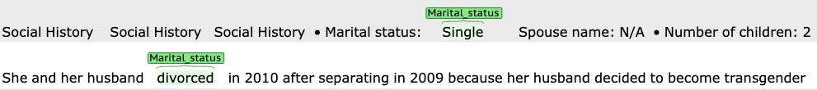

Education
We will annotate: 1) mention of education; 2) education level (7th grade, college, special program like nursing school or homeschooled); 3) education years
Concepts: Education
Examples:
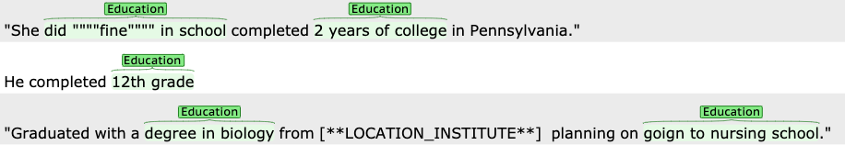

Employment
We will annotate 1) occupation – job position, title, specialty; 2) employment status such as employed, unemployed, retired; 3) working location – where the patients are working or worked at (e.g., Walmart)
Concepts: Occupation; Employment_status, Employment_location
Relation: Occupation to Employment_status and Employment_status to Employment_location
Examples:
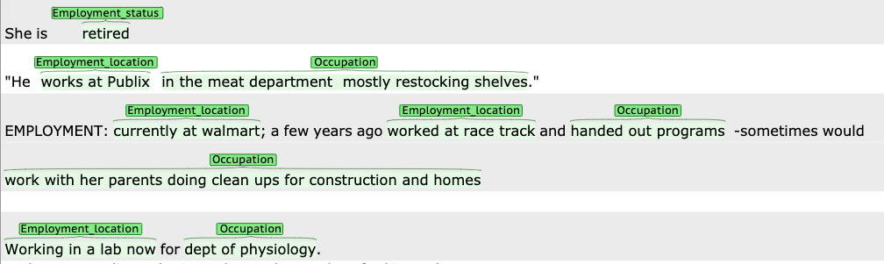

Working and Environment Risk
Working and env related risk such as pollusion or work-related condition like accessing chemicals.
Concepts: Working_Env_risk
Examples:

Gender/Race/Ethnicity
We will annotate 1) gender terms; 2) gender change (apply for transgender only)
Concepts: Gender; Gender_status
Relation: Gender => Gender_status
Examples:

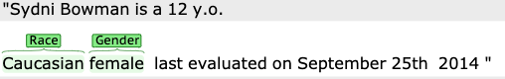

We will annotate the race of the patients (White, black, Asian etc.).
Concepts: Race
Examples:

We will annotate the ethnicity of the patients (Hispanic, Latino).
Concepts: Ethnicity
Examples:

Physical Activity
We will annotate 1) mentions of physical activity (Exercise is a subcategory of PA); 2) frequency (how long each time, how many times)
Note: definition of PA - activities involving any bodily movement produced by skeletal muscles that requires energy expenditure.
Concepts: Physical_act; Sdoh_freq; Sdoh_status;
Relation: Physical_act to others
Examples:
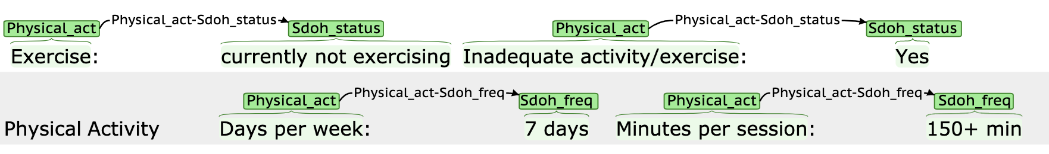

Living Condition
We will annotate mention of current living condition such as homeless, shelter, live alone, or live with others
Concepts: Living_Condition
Examples:
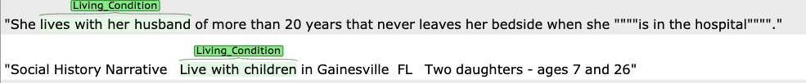

Living supply
We will annotate 1) food related mention (lack of food, food security); 2) water resource (safe water); 3) nutrition (well-nourished); 4) ability to access other supplies required for living (e.g., cloth). Housing will not be account for living supply.
Concepts: Living_supply; Sdoh_status
Relation: Living_supply to Sdoh_status
Examples:
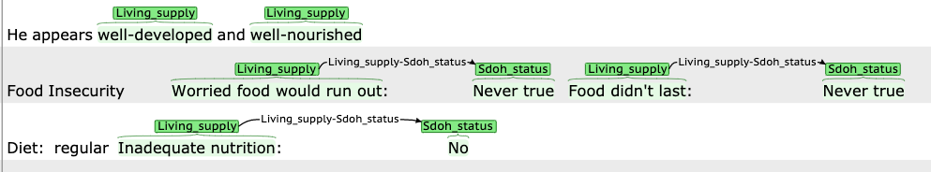

Poverty/financial constrain
Poverty – we will annotate the terms for poverty
Financial constrain – we will annotate the descriptions for financial constrain
Note: financial constrain only related to lack of money for doing something; poverty is a status that a patient lacks of every kind of resources.
Concepts: Poverty, Financial_constrain; Sdoh_status
Relation: Financial_constrain to Sdoh_status
Examples:
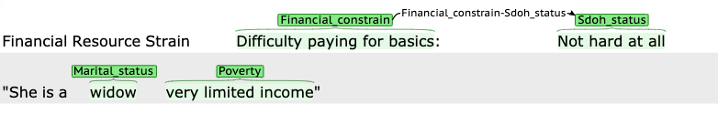

Language
We will annotate what language the patients speak, especially if the patients can speak/understand English.
Concepts: Language
Examples:

Literacy/health literacy
We will annotate any mentions related to patients have knowledge. For health literacy, the knowledge must be health related.
Concepts: Literacy; Health_literacy
Examples:

Abuse
We will annotate 1) general/physical/mental abuse (IPV will be merged with abuse, we do not annotate IPV anymore); 2) childhood abuse – we temporarily separate the childhood abuse from general abuse.
Concepts: Abuse; Sdoh_status
Relation: Abuse to Sdoh_status

Examples:
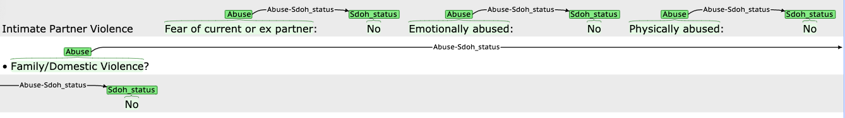

Public Safety
We will annotate mentions of personal safety concern not related to medical conditions. Any safety related to life such high crime rate, unsafe place to live. Food and water safety will not be included here but in living supply.
Concepts: Safety
Examples:

Transportation
We will annotate any terms related to patients interact with transportation system. Especially the ability to access transportation and requirement of transportation for medical purposes.
Concepts: Transportation; Sdoh_status
Relation: Transportation to Sdoh_status
Examples:

Social Cohesion
We will annotate any mentions of social participation (e.g., go to church), personal contacts with neighbors and friends, and building social networks. Any social activity including person-person or person-organization interaction should be considered.
Concepts: Social_cohesion; Sdoh_status; Sdoh_freq
Relation: Social_cohesion to others
Examples:
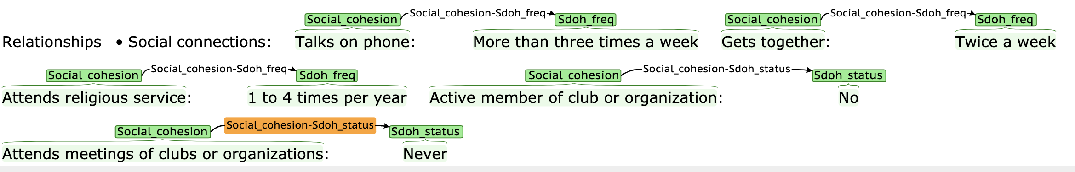

SDoH related ICD-10 codes
We will annotate the ICD-10 codes appeared in notes associated with SBDoH and environment condition (e.g., ICD-10 Z55-Z65).
Concepts: SDoH_ICD10
Examples:
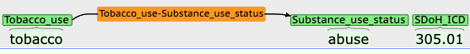

Other mentions related to SDoH but cannot be categorized.
We will annotate all SBDoH related information that cannot be categorized as other
Concept: SDoH_other
Examples:

What to do next?
When you meet a concept that not cover by the current examples, record it down and discuss with others. We will define a new category for each new appeared concept and what associated information we need to annotate.

